**Sol Tenebrae - AI component**

The game which hosts my AI component is called Sol Tenebrae, a top down dungeon crawler with hack and slash combo elements. The primary AI in this game are spiderlings, which have the ability to follow the player, attack the player, leap towards the player and, obviously, die. An interesting mechanic which I implemented is the AI’s ability to move to the last known location of the player, scan the surrounding area to see whether the player is still present and then return to its original guarding position.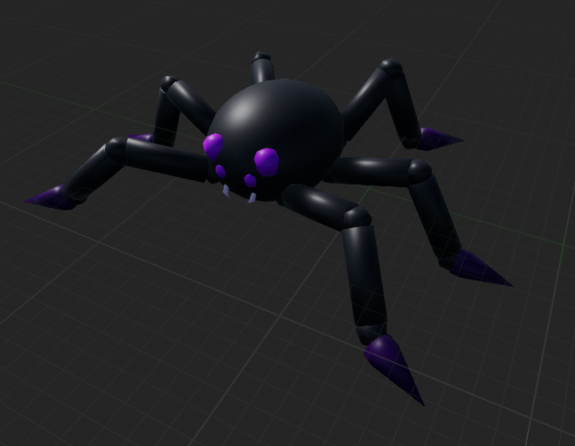

The reason I implemented the function for the spiders to jump is because I felt that is what spiders do in reality, they can remain stationary and appear to have frozen and then suddenly lunge at their target.

The overall narrative of Sol Tenebrae is that the player has found themselves in this creepy, dark castle and is fighting their way out through the dungeons (levels). With this in mind, it seems only natural to find spiders and webs in a creepy underground castle level.

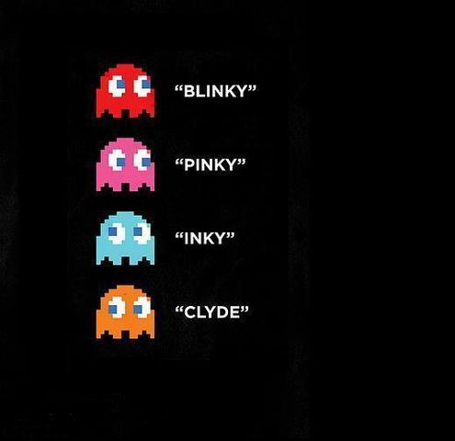

Furthermore, I intend to implement separate AI tracking personalities. For example, in Pac-man, the ghosts all have different personalities which are all used in tandem with the goal of capturing and defeating the player. This is what I wish to add to the current spider AI, so particularly: one personality to chase the player, one personality to attempt to corner the player by predicting their movement, one personality to attract more spiders and one personality to run away from the player.

The way I intend to program the spider to predict the player’s movement is to simply get the forward vector of the player character and set that as the destination for the spider, essentially chasing the player but always one step ahead. For the attracting spider I plan to integrate a pawn sensing component into the spiders to detect other spiders and to follow them when they appear, the attracting spider will move to a room where there are known spiders still alive.

**User stories**

* As a player I want to feel like I’m being swarmed by intelligent spiders as I traverse the dungeon.
* As a player I want incentive to be afraid of the spiders and reason to run away from them.
* As a player I want to be forced to think how I’m going to out-manoeuvre the AI to win
* As a player I want to be rewarded when I do kill the spiders
* As a player I want to be able to distinguish between the spiders and not have them all bunch up.